VITA CHEATSHEET TEMPLATE - DEC2011

Game title: Crystallon
Publisher: Crystallography
Release date: xx/xx/xxxx
Cheat sheet completed by: Ben Johnson

L button=
R button=
Up arrow =

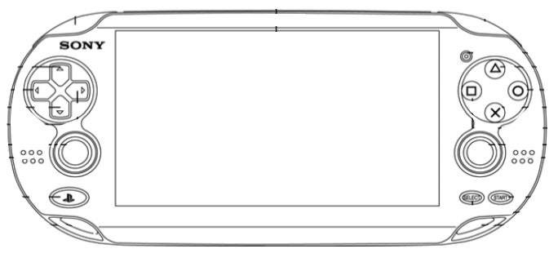
Left arrow =

Right arrow =
X = Back

Square =
Circle = Advance/ Next

Down arrow =

LEFT Analog stick =

Touch = everything

START = Pause

LEFT Analog stick =

Triangle =

